**Elastic Search PVC full around 85 %**

**Go to openshift-logging project**.

oc project openshift-logging

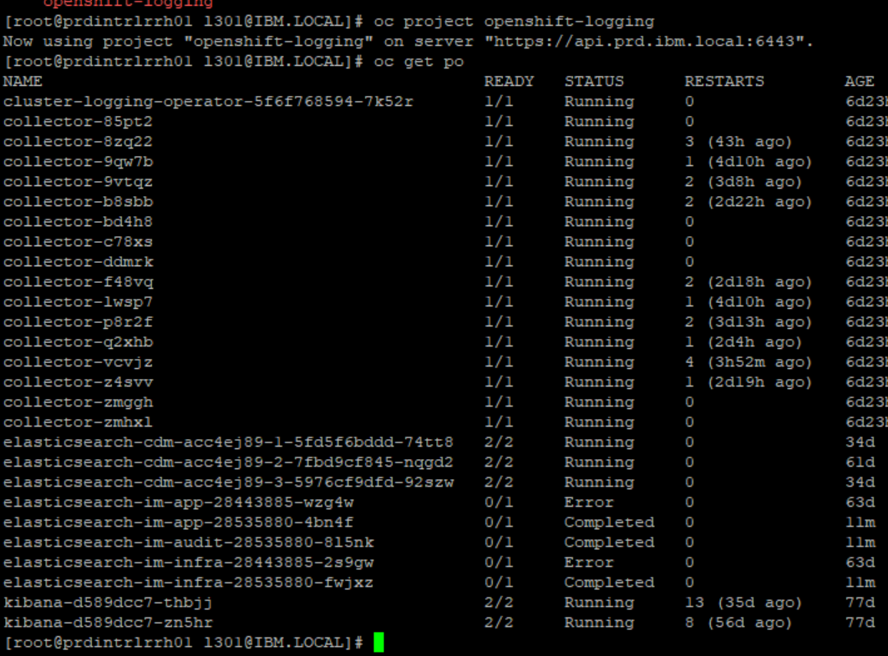

**Connect to any one elasticsearch-cdm POD**.

oc rsh elasticsearch-cdm-acc4ej89-1-5fd5f6bddd-74tt8



**Check for /elasticsearch/persistent mount point utilization using df -h.**

**List the app indexes with below command.**

es_util --query=_cat/indices?h=i,creation.date,creation.date.string,store.size,pri.store.size|grep app

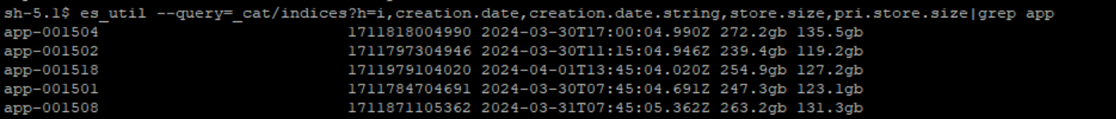

**Look for the oldest indexes , elastic search stores the logs for 7 days , so we need to delete last 7 date index.**

Eg: today is 3rd April so we can delete the index of 28th March if space is full.

Use below command to look for 28th March index.

es_util --query=_cat/indices?h=i,creation.date,creation.date.string,store.size,pri.store.size|grep app|grep 2024-03-28

Delete the indexes of 28th March.

es_util --query=app-001485 -XDELETE

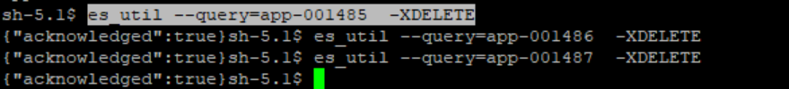

**Check the space again.**

